**BEIJING CAPITAL AIRLINES   
BUSINESS ANNOUNCEMENT  
*RECIPIENTS: Beijing Capital Airlines Concerned Departments   
SENDER: Beijing Capital Airlines Sales& Marketing Department***

***Issuer: Xu Jingbo Handler：Liu Pengcheng Tel：010－87429841***

***Send copy: International Business Segment***

**Fare Manual of Beijing Capital Airlines   
International Routes**

This document dated from the day after the issued day is immediately into effect.

Detailed information is shown in the following chapters.

Notice is hereby given.

Beijing Capital Airlines sales & Marketing Department  
Nov 7th, 2019

**Special Notice:**

1. Due to adjustments of international routes and published fares, the fare sheets for international routes are not included in this manual, Please refer to the GDS for details.
2. Because ADDON, SPA fare changes frequently, they are not included in this manual, Please refer to the GDS for details.
3. Due to adjustments of international routes, the free baggage allowances for international routes are not included in this manual. Please refer to policies issued for international routes’ Baggage Provisions.
4. Due to adjustments of international routes, the transfer and stopover provisions for international routes are not included in this manual. Please refer to the regional rules’ policies.
5. All sales offices must comply with the MCT at the time of sale. It is strictly prohibited to sell an interline ticket of which the connecting time is less than the published MCT. Ticketing offices that fail to follow this rule are fully responsible for the consequences. The ground service department notice for MCT shall prevail.

If the contents of this manual have been changed after issued, please refer to the latest business notification of JD.

**Abbreviations:**Beijing Capital Airlines - JD  
RBD - Reservation Booking Designator  
RT - Round Trip  
OW- One Way  
GDS - Global Distribution System  
PNR - Passenger Name Record  
FBA - Free Baggage Allowance  
EBC - Excess Baggage Charge

MCT- Minimum Connecting Time

GIT- Group Inclusive Tour

IIT- individual Inclusive Tour

**Table of Contents**

Part I - General Rules for IIT 5

Part II - GIT Rules 18

Part III –Baggage Provisions 21

Part IV - Appendix 24

Annex I - Airline Ticketing Service Reminder 24

Annex II - Regulation on Passenger Ticket Refund due to Illness in Capital Airlines International Flights 26

Annex III - Operation Rules of JD International/Regional Manual Ticketing 29

# Part I - General Rules for IIT

1. **Scope Of Application:**  
   This manual applies to all oversea sales branches of Beijing Capital Airlines (JD) and its designated ticket agents. The Sales and Marketing Department of JD reserves the right of final interpretation.

**2. Validity:**

Execute from the day after the issued day (Nov. 16th, 2019). Since the issued day of this policy, the primary《JDIR18046 Fare Manual of Beijing Capital Airlines International Routes2018-12-12》is discontinued.

**3. Class Mapping of International and Regional Sectors Operated by JD:**

Business Class: C/D/Z/I/R/J. J class is reserved for free of charge tickets.

Premium Economy class: W/E

Economy Class: Y/B/H/K/L/M/X/V/N/Q/P/A/U/T/G/S/O.

G class is reserved for GIT; U/T class is reserved for through fare; S class is reserved for redemption of Fortune Wings Club miles; O class is reserved for free of charge tickets.

**4. V.V. (vice versa) is not applicable (except for ADDON and SPA sectors).**

**5. 1/2 RT Fare Combination:**On a half RT basis, the combination between fares of JD international & regional **outbound** sectors is permitted, which can form a RT /OJ journey (unless otherwise specified), in which case the most restrictive tariff will apply for the entire journey. When outbound and inbound flights depart in the middle of week or over a weekend, the fare will be the combination of midweek fare and weekend fare.

For example: A passenger has booked a round-trip ticket for L and X respectively, so the total fare for the entire journey is the combination of half of L class RT fare and half of X class RT fare, the X class tariff applies to the combined fare. The fare basis should be input respectively.

**6. Children/ Infant Discounts**

**(Notice: whether a child or an infant discount is applicable refers to their age on the date of commencement of travel on the first JD international or regional long-haul sector)  
(1) Children Discount**

A Child is defined as a person who has reached his/her second birthday but not reached his/her 12th birthday (2-11 inclusive).

1) Children fare is 75% of applicable adult fare (if this tariff applies to children discount). “CH25” should be added after the applicable FAREBASIS.

2) The fuel surcharge standard for a child is the same as that of an adult. Children are not required to pay the Civil Aviation Development Fund fee. The tariff rules are the same as adults.

3) In special circumstances, when the adults and children are not reserved in the same PNR, the child’s PNR should be remarked “RMK adult ticket number” when issuing children ticket with 1E system.

4) When purchasing children's tickets on JD’s website, it should be booked with the accompanied adult together. If the child’s ticket was wrongly issued as adult’, this ticket should be refunded voluntarily, and a new ticket should be reissued.

5) Minors must be accompanied by an adult over the age of 18. If a minor is not accompanied by an adult but meets JD’s unaccompanied minor transportation conditions, the minor may make use of the unaccompanied minor service; otherwise, unaccompanied minors are not allowed. Minors traveling with an adult must purchase tickets with the same cabin as the accompanying adult. If passengers wish to purchase tickets in different cabin for an adult and a minor, the minor may use the unaccompanied minor service if the minor meets JD's unaccompanied minor transportation conditions. The minor must occupy a seat for the purchased cabin. If the minor does not meet JD's unaccompanied minor transportation conditions, the minor is not permitted to buy a ticket in a cabin different from that of the accompanying adult.

Notes: Please refer to the Ground Service regulations for the definition of unaccompanied minor and operating rules for handling the unaccompanied minor service.

6) Every adult passenger, who is over 18 (inclusive) and has full capacity for civil conduct, may carry up to five children, if children amount are more than five, the other children ‘s tickets can be issued as UM.

7) Unaccompanied minors are not eligible for a children discount; the adult fare applies. UM is exempt from the charge of civil aviation development fund.

8) If a child reaches 12 years old during the journey, the difference between children fare and adult fare will not be charged for JD operated sector. If the itinerary includes segments operated by other airlines, please refer to the provisions of the corresponding airlines.

**(2) Infant Discount**

An infant is defined as a person who has not reached his/her second birthday (under the age of 2) as of the date of commencement of travel on the first JD international route sector. Unaccompanied infant is not eligible. Infant ticket must be issued at the same cabin as the accompanying adult.

1) Only one infant not occupying a seat is allowed per accompanying adult passenger. Only infants not occupying a seat are entitled to the infants’ fare (if this tariff applies to infant discount). “IN90” should be added after the applicable FAREBASIS.

2) Infants occupying a seat (identified as INS) shall be charged the applicable child’s fare. If there is no children discount for this tariff, the adult fare should be applied.

3) If an infant reaches 2 years old during the journey, the difference between infant fare and children fare will not be charged for JD operating sector. If the itinerary includes segments operated by other airlines, please refer to provisions of the corresponding airlines.

4) Every adult passenger over the age of 18 and who has full capacity for civil conduct can carry no more than 2 infant passengers.

5）There is no penalty fee for rebooking, rerouting and cancellation of infant (infant without seat) tickets.

6）Fuel surcharges and the Civil Aviation Development Fund fee are free of charge for infant tickets.

**7. Definition and provisions for international students**

⑴ International students in educational establishment: Chinese students who study abroad or foreign students who study in China. If the international student is less than 12 years old at the date of commencement of travel, he/she may only enjoy the price discount, no more baggage allowance is offered.

‘Educational establishment’ means a school, college or university offering full time educational, vocational or technical courses for a school year. This does not include a commercial office, industrial or military establishment or a hospital at which a student is serving an apprenticeship unless it is part of the school curriculum of the educational establishment at which the student is enrolled. Visitors or tours to educational establishments, other than that at which the student is enrolled do not qualify.

⑵ Eligible passenger: International students and their immediate family members (including parents, spouse, sons and daughters)

⑶Ticket issuing rules: Input SD (applicable to student) or ASD (applicable to family member) after the name of the passenger in “NAME OF PASSENGER” field. In order to ensure passenger enjoy the special baggage allowance, please use QTE:SD/JD command when quoting the fare.

⑷ Rules for buying ticket: Passenger should provide a copy of their passport and student card or Certificate of Admission; the ticket number should be added to the copies as the settlement certificate. Up to 2 family members accompanying international student may have a ticket issued as the student fare. If the family members of the international student are children or infants, the family members can only enjoy the price discount, no more baggage allowance is offered.

The family members must provide appropriate documentation that is able to prove their identity and relationship to the international student passenger ready to present for verification throughout the journey. Other kind of certificates (such as an ISIC card) is not accepted as proof of international student status.

⑸ Travel Restrictions :

International students and family members should make reservations on the same outbound flight; the return flight has no such restrictions.

**8. Sales Rules:**

1. The tariff rule in this manual is valid for 898 tickets, for which JD is the validating carrier.

Notes: This provision is also applicable to the JD international charter flight IIT sale, except specified in the contract for the charter flight.

⑵ IIT ticket must have a reservation on the outbound trip;” OPEN” status is not allowed.

⑶ without special announcement the flight date refers to the commencement date of travel on the first JD international or regional sector.

Seasonality is determined by the date of commencement of travel on the first JD international or regional long-haul sector.

⑷ Tickets for special passengers must be issued at a JD appointed sales office, providing that the arrangements to accept the passenger have been made. For more information, please call the JD 24 hour hotline 95375. For interline flight, the passenger may call the operating carrier to know the relevant provisions first. You must conform that you can purchase ticket at our company before issuing the ticket. If the passenger fails to contact the operating carrier due to his/her own reason, which leads to miss a connection flight. The passenger shall take the responsibility by his own.

⑸ Passenger should prepare and provide all the necessary and valid certificates for taking the flights. If the passengers are denied boarding due to invalid certificates, JD will take no responsibility.

**9. Entry API Information:**

ADPI：/P1（Passengers serial number）the format of the instruction is below: the information between the horizontal lines must be entered）：

SSR DOCS JD HK1 ID Type/Country of issuing license/ID Number/Nationality/Date of birth/Gender/Valid period of Documents/Passenger NAME(copy as passport)/ Identification of the holder H/Pn

SSR DOCO JC HK1 birthplace /Type V/VISA No./Place of issuing the card/the date of issuing the card/Valid country or the region of the card/Identification of Infants I/Pn

America route need to be input in the following format:

SSR DOCA JD HK1 D（indicating the destination）/Country/Detailed address/City/information of the located province, city(state) /Postcode/I Identification of Infants/Pn

SSR DOCA JD HK1 R（indicating the place of residence）/Country/detailed address/City/ information of the located province, city(state) / Postcode /I Identification of Infants/Pn  
 **10. Provisions for Issuing Ticket:**

1. The ticket Time limit should refer to the earlier one between the time limit shown in the GDS and the time made by the booking unit
2. The correct passenger codes should be added after passenger’s name (e.g. SD, CHD, INF (infant without seat), INS (infant with a seat) etc.).Titles such as MR/MS are not mandatory.

(3) **“FARE BASIS” BOX:**

1) Input fare basis corresponding to the booking class in the fare table.

2) Children: input “CH25” after FARE BASIS;

Infants: input“IN90” after FAREBASIS.

(4) **“ENDORSEMENT / RESTRICTION” BOX：**

Input “Q/NON-END/PENALTY APPLY”，which means that ticket shall be honoured in sequence; Endorsement is not allowed; for details on re-book/refund, please refer to the corresponding tariff rules.   
Refund/re-book time refers to the time of changing the PNR in the system.

(5)The quoted fare using auto-pricing command in GDS should be settled at the face value of ticket. The quoted fare using manually-pricing command in GDS, the complete tour code and fare basis must be input as per fare policy. If only one policy is used, the corresponding tour code should be input in TC box correctly and completely. If the fare is a combination between two policies, input the first tour code in TC box correctly, the second tour code should be input with the format ”FC XXXXX TEXT/TC TOURCODE” in the FC box correctly and completely.

If the tour code has been changed after the ticket is exchanged, input the new TC in the tour code box.

(6)**“NOT VALID AFTER” box**：  
1) Input the return journey’s coupon validity using the more restrictive booking class’s tariff.

2) When selling the fare with a maximum stay requirement, there should be an annotation of the expiration date. If the expiration date is beyond, an upgrade of the booking class should be made.

3) If passenger requests to change the departure date of the JD international/regional sector, the return journey’s coupon validity should be recalculated according to the new departure date of JD international/regional sector, the “NOT VALID AFTER” box should be amended as well (handled by JD authorized sales office or 95375).

For example: TAO-MEL-TAO international sector booked in L class, fare validity is 6 months. The departure date is 01 Jun, so the fare is valid until 01 Dec. If the departure date changes from 01 Jun to 05 Jun, then the new deadline will be 05 Dec; if the departure date changes from 01Jun to 25 May, then the new expiration date will be 25NOV.

(7) Coupon validity:

The period of validity should be calculated from the commencement of travel date of the first JD international & regional long-haul sector; the deadline is determined by the travel date of the last JD international &regional long-haul sector (local time).

For example : the itinerary is PEK-TAO-MEL-TAO-PEK, international sectors are all booked in L class, fare validity is 6 months, then TAO-MEL-TAO can be completed within 6 months.

**11. Sequence of sectors listed in the ticket:**

Tickets booked in all cabins of Beijing Capital Airlines (JD) international& regional sectors shall be used in sequence. The ticket will lose its validity if the coupons are not used in the sequence provided in the ticket. For **t**ickets booked on RBD U/T, if the ticket is partially used, unused sector are not permitted to be refunded (tax is refundable).The ticket is permitted to be changed, then used sequentially. For tickets booked in other RBDs, those with an unused sector are permitted to be refunded within the period of validity; the ticket is also permitted to be changed, and used sequentially.

If passenger cannot use the itinerary listed in the ticket sequentially for an irregular flight reason, the ticketing transaction is referred to the provisions published about JD international irregular flight regulations.

**12. Voluntary Changes (including the voluntary change of date/ RBD/flight/routes, change of passenger name is excluded. For the involuntary change, please refer to <JD Ticketing Rule for JD international/regional irregular flights>.**

1. **How to Choose Applicable Fare and Calculate Fare Difference after exchange**

When calculating the new ticket fare after exchange. The fare should be calculated in combination with the original ticket flight information; the applicable lowest fare should be selected as long as all the applicable fare rules are met.

**Changes for partially used ticket:**

The new ticket fare will be based on the fare in effect on the date of original issue.

**Exchanges for totally unused tickets:**

1) Once the outbound sector has been exchanged, the new ticket fare should be calculated on the fares applicable at the time of commencement of the new transportation.

2) If only the return trip is exchanged, the new ticket fare will be based on the fare in effect on the date of original issue.

If the new fare is lower than the previous, the fare difference is non-refundable; if the new fare is higher than the previous, the fare difference should be paid by passenger.

1. **How to Calculate Tax Difference after exchange**

The differences of taxes are still calculated according to the principle of not refunding the excess payment but repaying the deficiency.

**⑶the principle of the change fee selection criteria**

1) The highest penalty fee applies for the changed sectors of the previous ticket.

2) The change fee should be charged for each time, and it should be non-refundable when refunding ticket.

3) When change date and other changes are made at the same time or several sectors are changed at the same time, change fee shall be charged once. If changes are done separately, the penalty fee established for each time applies.

When changes are made before the departure time of the change sector, NO-SHOW fee should not be charged. When changes are made after the departure time of the changed sector, NO-SHOW fee will be charged.

No-show fee applies for the highest penalty fee of the entire ticket, and is collected according to whether the passenger cancelled the seat in the PNR before departure.

**⑷The exchange rate selection criteria**

The exchange rate will be based on the rate at the time of exchange.

* **How to calculate the fare when JD international/regional sector interlines with sectors operated by other airlines**

1. If the public fare by the segments of other airlines is used, the price quoted as per QTE:/JD instructions should prevail when JD tickets are used to calculate the fare published by other airlines. The fare must be collected as per the price and corresponding booking class published by the single segments of other airlines. The price for carrier segments of other airlines in FC column must be consistent with the price published by the other airlines, and the par value of IT or zero par value shall not be entered.

⑵ Credit exchange ticket, discount ticket should be issued with IT par value. Special instructions: When upgrading a ticket with credit exchange, it is not permitted to increase the face value of the ticket artificially and should copy the original ticket FC.

⑶ Special Instructions:

For an open date ticket, making a reservation for the first time is free of charge; a penalty fee will apply to subsequent changing reservations.

* **Ticket change Due to Illness Reason**

If passenger requests to change ticket for illness/medical reason, after the necessary documents are provided, rebooking within the same cabin is free of charge. Ticket not permitted to be rebooked can also be rebooked without a change fee. For the upgrade of cabin due to a ticket change, the fare difference should be paid. For a fare change due to ticket change, the difference between the new fare and the original should be calculated. If the new fare is higher than the original, the fare difference should be paid; if the new fare is lower than the original, the fare difference will not be refunded. However, the following conditions must be met for an illness/medical waiver:

Passenger should request to change ticket prior to flight check-in time, and cancel the seat; the ticket should be changed the same way as an involuntary change at the original issuing place or the JD authorized office. The contents (generally to include passenger name, time and symptoms of the illness) of the certificate for involuntary change must be accurate and may not be altered. If not, the certificate will be deemed as invalid, and ticket cannot be changed for the reason of illness. When changing a ticket for an illness/medical reason, passenger should provide original certificate. Certificate should be examined and witnessed by the sales clerk and signed. The document submitted to the financial department should preferably be the original; however, if the passenger requires the original for reimbursement purposes, a photocopy is also acceptable.

1) When passenger requests to change a ticket for illness reason prior to check-in deadline:

A. In mainland China, the valid certificate should be: a regular diagnosis proof with the signature of the attending doctor and the official seal of the county or above level hospital, or patient’s medical record, or any receipt of medical fee over 300CNY. The issuing/printing date/time of these certificates must be prior to the flight check-in deadline.

B. Overseas or in Hong Kong, Macao and Taiwan, diagnosis proof must be filled by a qualified doctor recognized by the respective government. In Africa, diagnosis proof can be made by a Chinese medical institution. The requirement for the date of the patient medical record, receipt and the printing of certificate are the same as above.

2) When the passenger requests to change a ticket at airport due to sudden occurrence of illness: the certificate should be the diagnosis proof issued from an airport medical center. If the certificate cannot be provided immediately, the chief attendant or station manager should sign signature in order to obtain approval.

3) If accompanying persons request to change ticket along with the ill passenger at the same time, the ticket can be handled the same way as an involuntary change. If the accompanying person does not change at the same time with the ill passenger, this ticket change will be operated as voluntary change. The number of accompanying personnel entitled to this change cannot exceed two. If the accompanying person is the ill passenger’s immediately family, there is no number limit.

4) If passenger requests to change ticket due to the death of an immediate family member, the request should be made before commencement of travel. As long as the Certificate of Kindred and Certificate of Death of family member (Certificate of Death issued after the ticket issue date) are provided, the ticket can be handled as involuntary change.

**13. Voluntary Refund**

**(1) Location of Refunding Ticket**  
1) In principle, the location of voluntary refund should be at the original point of issue. When refunding the ticket, the necessary certificate (e.g. passport etc.) should be provided. If a passenger entrusts a person to refund ticket, that entrusted person’s certificate and letter of authorization written by the passenger are also necessary.

2) For the involuntary refund, please refer to <JD Ticketing Rule for JD international/regional irregular flights>.

3) If a passenger cannot refund ticket at the original place of issue due to special reasons, the passenger can request to refund the ticket at a JD authorized ticket office (not the original issuing place). The ticket office where the ticket is refunded, should receive authorization from the original place of issue first, according to the following procedures:

① The refunding ticket office may contact the agent by email to confirm the sale price (CCing the issuing ticket office for their records) and obtain the agent’s written consent.

②Alternatively, the issuing ticket office may contact the agent by email to confirm the sale price and obtain the agent’s written consent. Ticket offices can only refund tickets issued in a different location after obtaining authorization. They should convert the refund into the local currency using the system exchange rate, based on the refund amount provided by the original ticket issuer.

③Ticket offices that cannot locate an overseas ticket issuer should contact the Capital Airlines financial settlement department to confirm the actual sale price of the ticket. Then they should directly refund ticket based on the refund amount provided by the financial settlement department, converting it into the local currency using the system exchange rate.

**(2) Deadline for refunding ticket:**

If the ticket is totally unused, it can be refunded within 12 months from issue date; if a ticket is partially used, it can be refunded within 12 months from the date of commencement of travel of the first sector listed in the ticket.

1. **JD will not refund a ticket in any of the following cases:**1) Beyond the expiration date of refunding ticket.  
   2) Failed to provide valid Certificate or ticket submitted is invalid.  
   3) Partial refunding is not permitted for totally unused ticket.

**(4) Calculation of amount to be refunded for voluntary refund:**1)For a totally unused ticket: Deduct the refunding fee applicable to the ticket, the remaining amount should be refunded to passenger.  
2) For a partially used ticket:

1. If only the addon coupon is used, deduct the addon sector’s OW published fare on the date of commencement of travel, and charge the ticket’s penalty fee; the remaining amount should be refunded to passenger.

(B) If ADDON and JD international sector are both used, for the ADDON sector deducting the ADDON fare, and deducting JD international sector corresponding OW published fare of booking class on the day of commencement of travel, and charge the ticket’s penalty fee, the remaining amount should be refunded to passenger.

(C) If all JD international/regional sectors and sectors carried by other airlines are used, JD ADDON sectors can be refunded without a refunding fee.

(D) If the original cabin of used sectors has no OW published fare, deduct the published fare of its next higher cabin, the fare and coupon validity of which should be higher than original one.  
3) Children refund ticket is handled the same way as adult passenger.

4)When passenger requests to refund an upgrading ticket：If ticket is totally unused, the fare difference should be refunded to passenger and the refunding fee applicable to the original ticket should be charged. If JD’s international sectors are totally unused and only ADDON/SPA sectors have been used, deduct the applicable OW published fare of used ADDON/SPA sectors and refunding fees applicable to the original ticket, the remaining amount (including the fare difference paid for upgrading) should be refunded to the passenger. If JD’s international sectors have been partially used after upgrading, deduct the published OW fares of used sectors and refunding fees applicable to the new ticket, the remaining amount should be refunded to the passenger. The fare difference paid for upgrading will not be refunded.

5) When the passenger refunds before departure, no-show fee will not be charged; when the passenger refunds after departure, no-show fee will be charged. The determination standard of collecting no-show fee is according to whether the passenger cancelled the seat in the PNR before departure.

If there is refunding after the ticket is exchanged, the exchange rate will be based on the rate at the time of exchange.

**(5)** Involuntary refund refers to 《JD international irregular flight ticket handle regulation》.

**(6) Taxes to be refunded**

1) Unused taxes should be refunded to passenger at the time of ticket refund. JD will refuse to refund taxes to passenger in any of the following cases：

A- Beyond the deadline of refunding ticket.

B- Identity Documentation or ticket submitted is invalid.

2) For a non-refundable ticket, fares and fuel are non-refundable, but the unused taxes should be refunded to passenger.

3) When the fare + fuel<refunding fee, the fare and fuel are non-refundable; the unused sector taxes will be refunded to the passenger.

**14 Provisions for ADDON/SPA sector**

⑴ADD-ON/SPA fare can only be combined with JD international/regional fare, and cannot be used separately. The tariff applicable to JD international//regional sector will apply to the constructed fare. When issuing ticket, ADDON/SPA sector and JD international/regional sector must be in the same fare component.

⑵Rules for combination between ADD-ON/SPA sectors and JD international/regional sector:

Economy class fare on ADDON/SPA sector can be combined with economy & business class fare on JD international/regional sector (except specified in the SPA agreement);

First/business class fare on ADDON/SPA sector can only be combined with business class fare on JD international/regional sector; combination with JD international/regional sector economy class fare is not permitted.

1. The above fare is IIT OW price, RT=2*OW; IIT ADDON/SPA sector fare does not apply to group travel.

# Part II - GIT Rules

1. **GIT Fare**
2. Group is defined as 10 or more passengers, excluding infants, traveling together.
3. 2-9 people can apply for a small team if the flight seats permit. If necessary, Please contact the local branch office.
4. Negotiated group application process is from the travel agent - the local branch office.
5. If there is no children/infant discount in group policy, the adult fare applies.

**2. Ticket entry**

⑴ “CLASS” box: Fill in the group class code. For example: “G”.

⑵ “FARE BASIS” box: Input fare basis corresponding to the group class. For example: “YGV10”.

⑶ “FARE” box: Input the GIT fare.

⑷ “ENDORSEMENT/RESTRICTION” box: Fill in according to the requirements of the corresponding policy.

⑸ “TOUR CODE” box: Input the tour code of the GIT fare.

⑹ open ticket is not allowed for any sector in group itinerary.

**3. Rebooking**

1. The group ticket cannot change itinerary or date once issued, except the situation that the passenger cannot travel due to his/her or their immediate family member’s death or illness according to IATA provision.
2. Passengers can change the ticket from the originally purchasing office; JD does not accept the passenger’s application of personal change.

**4. Refunding**

Normally, group passengers are not allowed to refund voluntarily (Except specified in the following provisions)

Normally, the airline company does not accept the passenger’s application of personal refunding. Passenger should refund the ticket at the original issuing office. Group passenger must apply for refund before the first coupon departure, and obtain the airline revenue manager’s confirmation. After the first coupon launches, voluntary refund application is not acceptable.

1. Refunding procedure
2. The ticket must be complete and valid.
3. Need identification document, such as passport.
4. Refuse to refund ticket in any of the following cases:1). Beyond the expiration date of refunding ticket.

2). Failed to provide valid Certificate.  
3). There is no amount to be refunded after calculation.

1. Refund provision
2. The fare of other carrier’s interline sector is non-refundable.
3. Tax is refunded only before departure, the fuel is non-refundable after departure, but the unused tax should be refunded.
4. Calculation rule for involuntary refund

1) For a totally unused ticket, the full amount of the actual payment when purchasing the ticket will be refunded without any charge.

2) For a partially used ticket, refund the amount which equals to the actual payment when passenger purchasing the ticket minus the corresponding group preferential price of the used sector (OW =1/2 RT), and refund the remaining amount to passenger, do not charge any fee.

For example, the group route is TAO-MEL-TAO, 18 people, 1 FOC.

TAO=MEL GIT OW 4200, RT 6400.

If the entire group member used TAO-MEL sector, passenger refund MEL-TAO sector involuntarily, whatever how many passengers refund, refund 3200 to each person. (note: FOC ticket holder is non-refundable.)

**5. Group ticket reservation procedure**

⑴ In addition to the travel route, group tickets reservation must provide the following information:

1) Group name (passenger number +JD travel agent name +free text, e.g. JDCITS);

2) Passenger name;

3) Travel agent telephone;

4) Any special service requirements;

5) Indication of collecting deposit: after collecting the travel agent deposit, indication must be remarked in team PNR as “SSR OTHS SPA DEPOSIT COLLECTED”.

⑵Group reservation special requirements for interline journey between JD and other carriers

After the group PNR is created, indication must be remarked in the PNR as “SSR GRPS XX GRP FARE CNY XXXX”.

# Part III –Baggage Provisions

**1. IATA Resolution 302 (for non-U.S./Canada routes)**

Baggage provisions are defined as free baggage allowance rules and baggage charges. For the purposes of baggage provisions selection, the following 4 step process should apply for interline journeys:

Step 1: If the published baggage provisions among all participating carriers are the same; these provisions will apply.

Step 2: where the one or more published baggage provisions differ between participating carriers, apply any common provisions and where provisions differ the published baggage provisions of the Most Significant Carrier (MSC).

In case of code share flights this will be the Marketing Carrier, unless that carrier publishes a rule stipulating that it will be the Operating Carrier.

Step 3: If the MSC does not publish baggage provisions for the journey concerned apply the publish baggage provisions of the carrier accepting the baggage at check-in.

Step 4: If the carrier accepting the baggage at check-in does not publish baggage provisions for the interline journey concerned apply the published baggage provisions of each operating airline sector-by-sector.

Remark: The principles for selection of MSC (one MSC for each baggage portion) are as follows:

⑴For travel between two or more Tariff Conference areas, the carrier performing carriage on the first sector that crosses one area to another.

Exception: TC123 only, the carrier providing carriage on the first sector that crosses between TC1 and TC2.

i.e. the journey is MAD-JD-X/TAO-HX-HKG, and also a baggage checked portion, the sector that first crosses areas is MAD-TAO(TC2 to TC3),so the carrier of this sector “JD” is the MSC.

⑵For travel between Tariff Conference sub-areas, the carrier performing carriage on the first sector that crosses from one sub-area to another.

i.e. The journey is KRT-JD-X/DXB-KQ-NBO, and also a baggage checked portion. The journey is within TC2, the first sector that crosses one sub-area to another is “DXB-NBO” (Middle East sub-area to Africa sub-area), and the carrier of this sector “KQ” is the MSC.

⑶For travel within a Tariff Conference sub-area, the carrier performing carriage on the first international sector.

i.e. the journey is TAO-JD-X/BKK-GA-SIN, and also a baggage checked portion, the journey is within the Southeast Asia sub-area in TC3, the first international sector is TAO-BKK(China P,R to Thailand), the carrier of this sector “JD” is the MSC.

**2. IATA Resolution 302 (for U.S./Canada routes)**

⑴ For passengers whose ultimate ticketed origin or destination is a U.S/Canada point, the baggage provisions selected at the beginning of the itinerary shall apply throughout the journey, regardless of stopovers.

i.e. the journey is TAO-JD-SEA-F9-DEN-F9-SEA-JD-TAO, passenger departs from TAO and the ultimate destination is DEN in USA. Therefore, as the first carrier in the whole itinerary, JD baggage rules will apply throughout the journey, regardless of stopover.

⑵In the case of code share flights, the Marketing carrier’s baggage provisions will be selected.

**3. Notes to the sales offices:**

(1)The sales offices should print the free baggage allowance strictly according to the free baggage allowance automatically calculated in the GDS or the provisions specified in the fare policies, JD will accept the baggage according to the standard shown in the electronic ticket. If the sales office modifies the standard of FBA without authorization, which causes that JD carries more free baggage than the standard or results in passengers’ complaints if JD refuses to take the modified FBA：For the excess baggage, JD will charge excess baggage fees according to the provisions. The sales office should undertake all the responsibilities resulted from the passenger complaints. For serious cases, JD will punish the sales office depending on the situations occurred.

(2) When the transit time is over 24 hours between the ADDON sector operated by JD (including JD*) and JD international/regional sector, the GDS will automatically judge the ADDON sector to be a single baggage checked portion, GDS will show the baggage allowance of baggage checked portion. When checking in, the staff should guarantee with the standard applicable to the JD international/regional sector.

⑶The designator“A”can still stay in PNR even if changing the FBA manually while using automatically issuing command “DFSQ: A”.  
⑷For the tickets which cannot be quoted the correct fare or the correct baggage allowance in the GDS, the correct baggage allowance should be entered in the FC item when issuing the ticket; The GDS will limit the issuing of a ticket if the baggage allowance is not entered correctly.

⑸When issuing ticket, use QTE:SD/JD instruction to get the free baggage allowance. Qualifying passenger types such as international students who wish to receive an extra baggage allowance and have qualifying documentation, must show their ID when purchasing tickets for the first time. They may then receive an extra baggage allowance based on the specified passenger type for different routes. If the passenger request to enjoy the baggage preference after the ticket is issued, he/she can exchange the ticket freely at 95375 call center with valid certificate.

⑹The rebooking operation may cause several different baggage checked portions to become a single one ( the stopover disappeared in the journey between JD and other carriers ) or it may cause one checked baggage portion into 2 different checked baggage portion ( a stopover occurs in the journey between JD and other carriers). While rebooking, the baggage allowance should be modified in accordance with IATA baggage provisions.

⑺All sales offices should remind the passenger who may have excess baggage (overweight, over-sized or an additional piece) or special baggage, to arrive at the airport in advance in order to go through relevant procedures.

Part IV - Appendix

## Annex I - Airline Ticketing Service Reminder

1. Please ensure the travel documents and visa is valid. If the passenger holds a Chinese passport, please make sure that the passport is valid for at least 6 months; the validity will be calculated from the day the return journey starts; if the validity is less than 6 months, the passport’s validity must be extended prior to issuing the ticket. If you have any questions concerning travel documents and visas, please consult the consulate of the destination country directly for the most accurate immigration information.

2. Valid travel documents are necessary to purchase a ticket and board a flight. Passengers will be asked to show their passport when purchasing a ticket at JD’s ticket counter; when purchasing a ticket through a website, the passenger must complete passport information, Flight origin, transfer and stopover point and destination correctly. Passengers are responsible to obtain and retain the required documents on their own, according to the flight information and to ensure the documents are valid. Passengers should retain travel documents themselves and not put them in checked baggage. If the travel cannot start or is postponed for invalid, expired or missing travel document reasons, JD will not take any responsibility.

**3**. After a seat has been booked on JD’s international or regional flight, the ticket should be issued within the ticketing time limit; otherwise the booked seat may be canceled. In the event the passenger desires to cancel the booked seat on JD’s international or regional flight (including seats on a interline flight), he or she must contact JD’s ticket office or agent as soon as possible.

**4**. The ticket is a transportation document between the passenger and the airline company, and it is also a document for boarding the flight and reclaiming checked baggage at the destination airport. It can only be used by the passenger whose name is listed in the ticket, and cannot be transferred to any other person or changed the name.

**5**. If a ticket is being purchased for a child, an infant or a passenger requiring special assistance (including VIP, passenger with a medical condition, passenger with a physical or mental disability, stretcher passenger, pregnant, unaccompanied minor, etc.) on a JD international/regional flight, it is necessary to contact JD 24 hour hot-line 95375.

**6**. While purchasing a ticket, the passenger should pay the taxes according to government regulations. Due to effect of changing exchange rates and policies, the tax actually paid may fluctuate from time to time. Please issue the ticket promptly; the fare will prevail at the time of issue.

**7**. Tickets booked in all classes of JD international/regional sectors must use the itinerary listed on the ticket sequentially. In the event tickets are used out of sequence, the ticket will be deemed void.

**8**. In a passenger needs to re-book/refund a ticket or upgrade the cabin, one can apply to Capital Airlines, and do the re-booking, refunding or upgrading procedures at the point where the ticket was issued or any other JD authorized place, while the re-booking fee, refunding fee and fare difference should be paid.

**9**. JD provides free baggage allowance by the piece concept. The free baggage allowance will be provided to the passenger in accordance with the standard applicable to the route chosen. For details, please contact Capital Airlines 24 hour hot-line 95375, consult the clerk at JD’s ticket counter or visit JD’s website.

For matters not mentioned above, please refer to the terms & conditions under 《Civil Aviation Law 》published by CAAC, and《Beijing Capital Airlines General Conditions of International Carriage for Passengers and Baggage》governed by JD.

## Annex II - Regulation on Passenger Ticket Refund due to Illness in Capital Airlines International Flights

In order to demonstrate the service quality of our company, to better care for and help passengers who are unable to make a trip due to illness, the passenger ticket refunds regulations for illness in international flights of Capital Airlines is hereby formulated.

1. Types of Ticket Refunds due to Illness

1.1 Passenger requests to refund ticket due to illness prior to flight departure time.

1.1.1 Individual passenger shall request the refund and cancel the ticket prior to flight departure time;

1.1.2 Group passenger should request the refund through website prior to flight departure time.

1.2 The passenger requests to refund ticket at airport due to sudden occurrence of illness.

2. Sick note

2.1 The content of certificate (including passenger name, time and symptoms) must be accurate and may not be altered. If not, the certificate will be deemed as invalid, and ticket cannot be refunded as a sickness refund. When refunding a ticket for an illness/medical reason, passenger should provide original certificate. Certificate should be examined and witnessed by the sales clerk and signed. The document submitted to the financial department should preferably be the original; however, if the passenger requires the original for reimbursement purposes, a photocopy is also acceptable.

2.2 When a passenger requests to refund a ticket for illness reason prior to flight check-in deadline:

A. In mainland China, the valid certificate should be a regular diagnosis proof with the signature of attending doctor and the official seal of the county or higher-level hospital, or patient’s medical record, or any receipt of medical fee over 300CNY. The issuing/printing date/time of these certificates must be prior to the flight check-in deadline.

B. Overseas or in Hong Kong, Macao and Taiwan, diagnosis proof must be filled by a qualified doctor recognized by the respective government. For cases in Africa, diagnosis proof can also be issued by Chinese-funded medical institutions. The requirement for the date of the patient medical record, receipt and the printing of certificate are the same as above.

2.3 When passenger requests to refund a ticket at airport due to sudden occurrence of illness: the certificate should be the diagnosis proof of patient’s medical record issued from an airport medical health center. If the certificate cannot be provided immediately, the chief station manager should sign signature on passenger’s ticket in order to obtain approval.

3 Ticket Refunds Regulation

3.1 Passenger requiring the refund due to illness, may be refunded as involuntary refund.

3.2 If accompanying persons require a refund of their tickets along with the ill passenger, the ticket may be refunded at the same time, as an involuntary refund. The number of accompanying persons cannot exceed two. If the accompanying person is the ill passenger’s immediately family member, there is no number limit.

3.3 Group passenger refund due to illness reason before departure, if it affects the team's minimum number and FOC calculation, the group ticket price and FOC number need to be recalculated. Passenger refunds due to illness during the trip will not affect the price of other group members.

3.4 The sickness must be handled by the person, unless the illness is serious. In that case, the entrusted agent must handle the refund providing the original or copy of the passport of the sick passenger and the original identity document of the agent.

3.5 If the passenger is deceased, with a death certificate provided, the ticket can be refunded the same way as refunding for illness/medical reason.

3.6 If the passenger requests to refund a ticket due to the death of an immediate family member, the request should be made before commencement of travel. As long as the Certificate of Kindred and Certificate of Death of family member (Certificate of Death should be issued after the ticket issued date) are provided, the ticket can be handled the same way as illness refund.

3.7 Within one month from the date of submission of the refund, each sales unit (agency, call center) shall send the required information to the sales department/office of the company by mail or by e-mail scanning. The sales department/office/call center will then send the materials to the financial review. If the materials are not submitted within the specified time, they will be treated as voluntary refunds. After the completion of the medical evacuation procedures, if the passenger needs to retrieve the original materials, our company can send it back without postage payment.

3.8 In principle, the refund should be made before the flight departure. Under special circumstances, passengers can give reasonable explanations and provide evidence. It can also be processed after the flight takes off, but no more than one month later.

4 Refunding office

Call center of Capital Airlines, original issuing office.

## Annex III - Operation Rules of JD International/Regional Manual Ticketing

I. Requirements for manual ticketing：

Unrealistic nominal value for manual ticketing is strictly prohibited unless the policy stipulates. All the IT issue authorizations must be stated clearly within the corresponding sales policy; otherwise the ticket issuing unit is not allowed to issue IT tickets without authorization. Entry IT in Fare item, the Q/S/D values of IT tickets must be retained in FC.

When issuing IT ticket:

⑴ Modify FC: Delete the NUC values after each fare component; leave a blank input M/IT

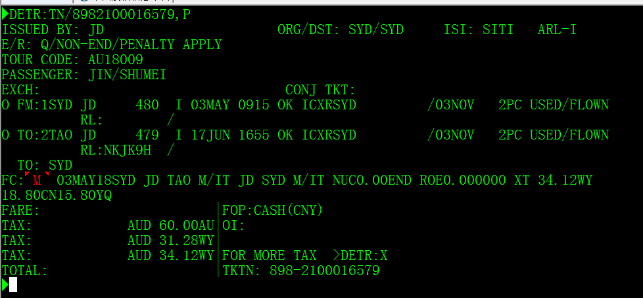

⑵ Modify FN: delete FCNY, input IT, while item S is the paid price.



⑶ Other items should be entered as normal tickets.

Note 1: Unrealistic par value refers to that the amount of item F is higher than that of item S, where item F is the par value, while item S is the paid price.

Note 2: Q is the surcharges; S refers to the surcharges at transfer and stopover; D is the difference of booking class.

Note 3: The above statements are all based on ETERM (1E) system (The same applies hereafter).

II. exchange tickets manually:

The exchanging unit must ensure the difference between the "Q\S\D-containing new fare" of new tickets and that of original tickets is charged correctly. If the NUC, Q, S and D in previous fare and FC calculation group are incorrect, the exchanging unit will not be held responsible for the calculation deviation of new fare value.

The specific requirements for manually exchanging tickets are stated as below:

1. Same itinerary

1.1 Change date in the same cabin, no change in both fare & fare basis

Do not exchange ticket, change flight date directly on original ticket without changing FC, only rescheduling fee is charged.

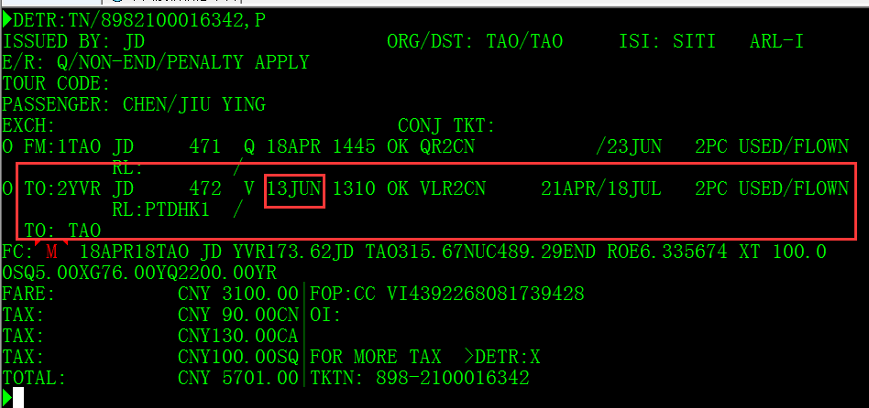

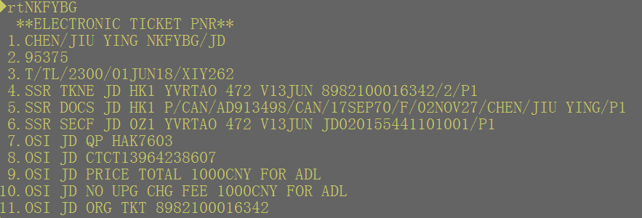

1.2 Fare or fare basis is changed

⑴ Totally unused ticket, fully exchange

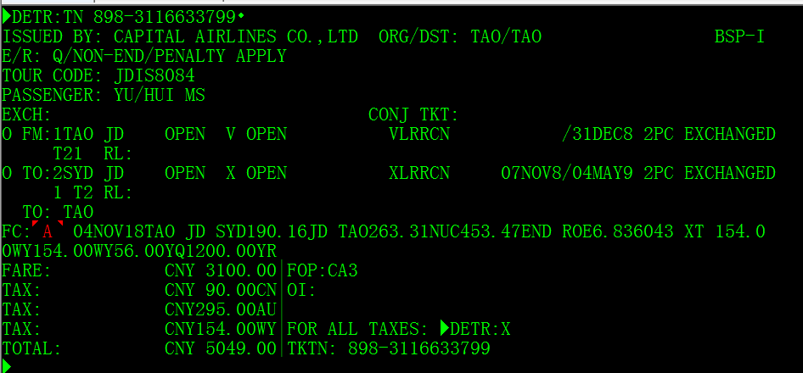

The FC content in the entire fare component of original tickets should be copied and replace the FC of new tickets. The routes involving changes in Q\S\D values must retain the Q\S\D values corresponding to the routes of new tickets. At the same time, "%TKT IT" should be indicated in text format at the end of the FC column.

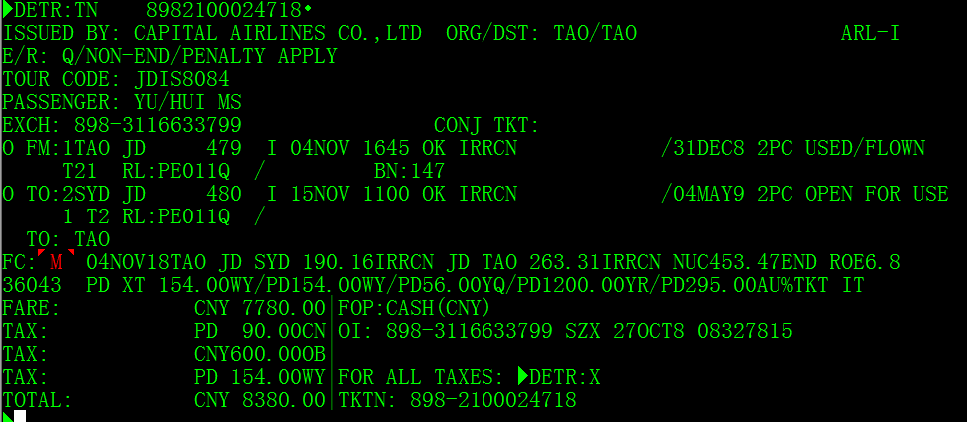

⑵ Partly used ticket, the exchanging coupon’s FC is unused

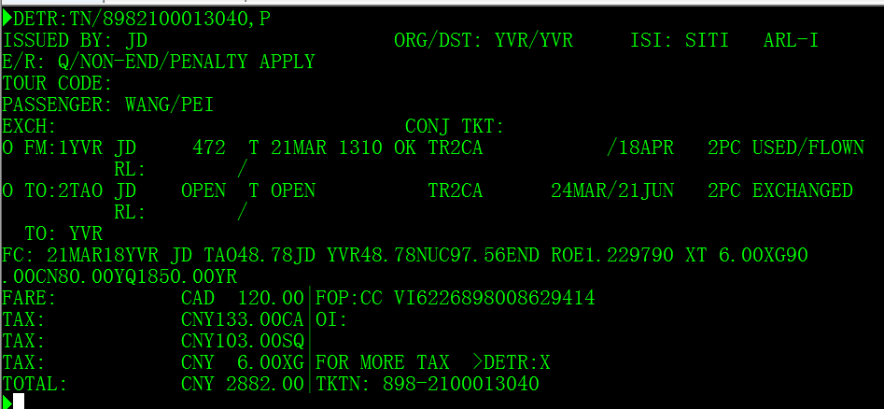

The original ticket has been partially used and the return journey has been exchanged. The FC content of the corresponding unused itinerary in the original ticket FC column is used to replace with the new ticket FC. The routes involving changes in Q\S\D values must retain the Q\S\D values corresponding to the routes of new tickets. At the same time, "%TKT IT" should be indicated in text format at the end of the FC column.

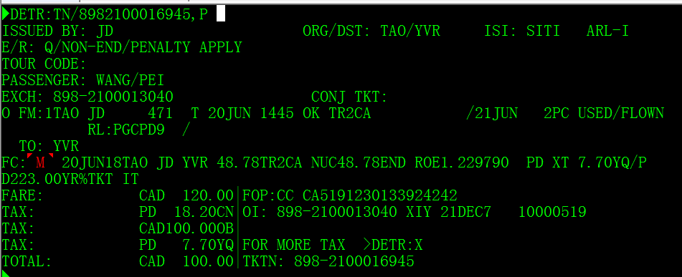

⑶ Partly used ticket, the exchanging coupon’s FC is partly used

If the routes partially exchanged is a part of one or more independent fare components of original tickets, the NUC value of all fare calculation groups involved in the actual routes of new tickets should be modified as 0.00. The routes involving changes in Q\S\D values must retain the Q\S\D values corresponding to the routes of new tickets, and the Q\S\D values should be added to the total NUC value. At the same time, "TKT IT" should be indicated in text format at the end of the FC column.

Case 1:

Old par value: MEL JD X/TAO JD HGH M326.65JD X/TAO JD MEL M119.22NUC445.87END

MEL-TAO-HGH is a fare component; HGH-TAO-MEL is a fare component.

① the route Melbourne-Qingdao has been used

Modify the FC format of new tickets:

FC:01SEP16TAO JD HGH M0.00 JD X/TAO JD MEL M119.22

- NUC119.22

- END

- / ROE6.566160

- / TEXT/TKT IT

② The route Melbourne-Qingdao-Hangzhou-Qingdao has been used

Modify the FC format of new tickets:

FC:01SEP16TAO JD MEL M0.00

- NUC0.00

- END

- / ROE6.566160

- / TEXT/TKT IT

Case 2:

Old par value: FC:20SEP16TAO JD X/MEL VA BNE M895.50 NUC895.50END ROE6.566160

The route Melbourne-Qingdao has been used

Modify the FC format of new tickets:

FC:20SEP16MEL VA BNE0.00

- NUC0.00

- END

- / ROE0.881606

- / TEXT/TKT IT

2. reroute

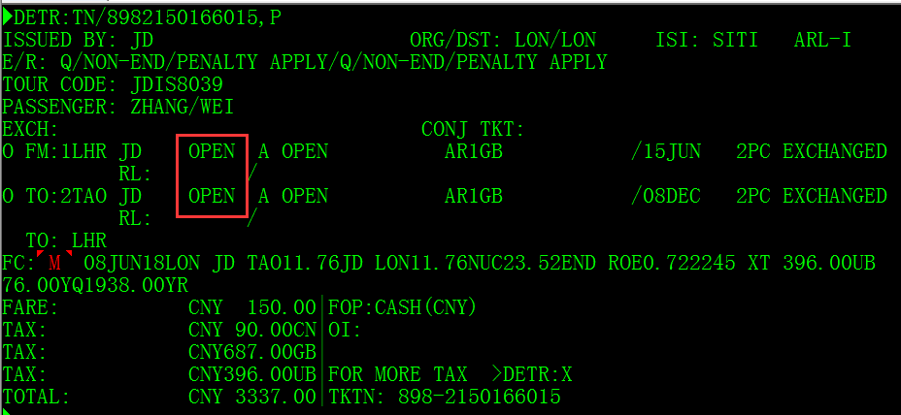

Input the exchanged coupon’s new date,cabin,fare basis in the exchanged ticket. Fill in the FC column and change the new NUC value, FARE BASIS of the ticket, “%TKT IT" should be indicated in text format in the end of FC column. Input the new fare in fare item, charge change fee in OB terms, and enter PD before the paid tax. TOTAL=fare difference +penalty fee +new tax. TOTAL=SCNY+XCNY=ACNY.

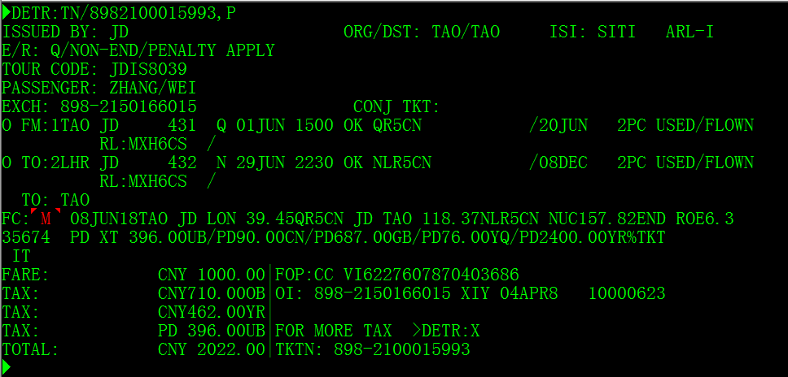

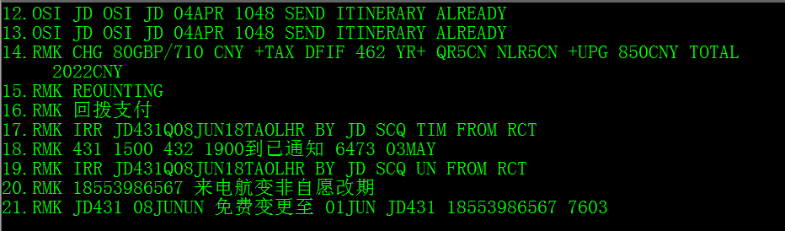

3 When the tickets containing SPA segments are exchanged manually and there is no agreed booking class for other airlines segments, passengers should be charged the price difference as per the public price of actual cabin instead of SPA price if non-agreed cabin tickets are issued. The requirements for FC are the same as Clauses 1-2 above.

III. Operation methods of exchanging tickets for private fare:

Private fare: It refers to the fare only used by some agents/sales departments/offices/websites.

When passengers exchange tickets through the sales channels directly controlled by JD, the sales channels should be authorize to enjoy the preferential fare standards specified in the corresponding policies on original tickets (excluding item C of agency fee), but the fare restrictions of new tickets must be consistent with original policies except for the restrictions on ticket agents. First-line units may inquire related policies through jdintlfare mail box.

Items R in FN column is the new ticket fare, items S in FN column are the price difference collected for new tickets. For the exchange of original tickets which have enjoyed fare preference like mark-down and depreciation: if the booking class has applicable preferential policy in original private fare policies after exchange, it is authorized to enjoy applicable preference as well, and the additional payment for the price difference of new tickets is equal to the price difference of two booking classes after preference; if the booking class has no applicable preferential policy after exchange, the additional payment for the price difference of new tickets should be the price difference between the applicable new fare of new tickets and the par value of old tickets. For the par value of IT tickets, it shall be handled by the original issuance unit except for irregular flights. In case passengers request assistance from JD or fail to contact the original issuance office, if the original ticketing policy is missing, they will be charged with the public fare.

Specific cases:

1. With applicable policy: If the M-class for Qingdao-Melbourne route enjoys 5% preference for its price RMB 1,000 and is upgraded to K-class that enjoys 10% preference for its price RMB 2,000, the price difference is calculated as (2000-2000*10%)-(1000-1000*5%)=850

FN:RCNY1800.00/SCNY850.00/C0.00

- /OCNY90.00CN/OCNY119.00US/OCNY1251.00XT/ACNY850.00

2. Without applicable policy: If the M-class for Qingdao-Melbourne route enjoys 5% preference for its price RMB 1,000 and is upgraded to K-class that enjoys no preference for its price RMB 2,000, the price difference to be additionally paid by passengers is calculated as 2000-(1000-1000*5%)=1050 as per the par value of original tickets RMB 950.

FN:RCNY2000.00/SCNY1050.00/C0.00

- /OCNY90.00CN/OCNY119.00US/OCNY1251.00XT/ACNY1050.00

The preferences above are only limited to fare discounts except for item C.

IV. Ticketing requirements for interline transportation of JD international and regional segments and external airlines

The "external airlines" mentioned below refer to all non-JD airlines.

1. If the segments of external airlines use the SPA fare specified in JD sales policies, the SPA segments of these airlines must fall in the same fare component with JD international/regional segments and must meet the applicable conditions of the SPA fare.

2. If the public fare by the segments of external airlines is used, the price quoted as per QTE:/JD instructions should prevail when JD tickets are used to calculate the fare published by external airlines. The fare must be collected as per the price and corresponding booking class published by the segments of external airlines. The price of external airlines segment in FC column must be consistent with the price published by the external airlines, and the par value of IT or zero par value shall not be entered.

3.For issuance of the tickets exchanged through reward points and preferential tickets which contain SPA and ADDON segments, the calculation columns for IT par value of item F and FC column should delete the NUC amount, while item S is the paid fare amount. When these tickets are exchanged, item F and item S are consistent and are both paid exchange amount, but the FC item of new tickets should still be filled as per the FC content of original content. If Q value exists, retain it. Other requirements are as specified in Clauses 1 and 2 above. External airlines segments must charge as per the price of ADDON/SPA agreement instead of the ADDON/SPA price. For the fare basis of tickets exchanged through reward points, the tickets shall be issued in the format agreed between JD and external airlines.

V. Special tips

The ticketing staff should note that even if the policy on manual fare does not contain or specify Q/S/D and other surcharges, when the FC column which quotes the fare in the system contains Q/S/D and other surcharges, they still need to add it to the paid fare of Q/S/D par value.